When Education Diverges from Law: LGBTQ Narratives in Jordanian and Egyptian Textbooks
Globally, the legal and social recognition of LGBTQ rights varies significantly, ranging from full marriage equality and comprehensive anti-discrimination protections in some countries to criminalization and severe punishment, including death, in others. Yet, legal status does not necessarily determine social acceptance or representation. State-mandated education, in particular, often functions as a social barometer, reflecting dominant moral consensus more than existing legal frameworks, which is evident from the examples of Jordan and Egypt.
The Middle East is home to many socially conservative societies, a reality that is reflected in the region’s human rights landscape. Attitudes toward LGBTQ individuals therefore vary widely across the region. Israel stands out as the most legally protective country for LGBTQ people in the Middle East; same-sex relations have been legal since 1988, same-sex couples are entitled to adoption rights and recognition of marriages performed abroad, and anti-discrimination protections are in place. Nevertheless, these protections still fall short of those found in many Western countries, particularly with regard to marriage equality and comprehensive legal recognition of transgender rights.
At the opposite end of the spectrum is Iran, which is widely regarded as the least protective country in the region for LGBTQ people in both law and practice. Under Iran’s penal code, same-sex relations are criminalized, with punishments that can include the death penalty, making the contrast between the two countries especially stark. However, while homosexuality is subject to harsh treatment across much of the Middle East, there are important distinctions in how transgender people and transgender rights are addressed. Although Iran and many other countries in the region explicitly criminalize same-sex relations and actively enforce punishments, attitudes toward transgender individuals are less uniform. In Iran, for example, homosexuality is criminalized and can be punishable by death, yet transgender people are granted limited legal recognition. Gender reassignment surgery has been permitted since the 1980s following a fatwa, though this recognition is framed not as an affirmation of gender identity, but as a medical correction of a perceived disorder.
While Israel and Iran represent the most protective and least protective ends of the spectrum for LGBTQ rights in the region, respectively, Jordan and Egypt offer particularly instructive intermediate cases. In both countries, homosexuality is not explicitly illegal: in Jordan, same-sex relations were decriminalized in 1951, while in Egypt same-sex relations are not criminalized but are frequently prosecuted under morality, public order, and “debauchery” laws. Despite this shared absence of explicit criminalization, the two countries differ in practice. Jordan generally confines its approach to social and religious disapproval, whereas Egypt has developed a pattern of de facto criminalization through arrests, prosecutions, and institutional stigmatization, including within state-approved educational materials. The treatment of homosexuality in Jordanian and Egyptian textbooks reflects prevailing moral and societal attitudes rather than the formal legal status of same-sex relations, demonstrating how education systems transmit dominant social norms even when these norms are not codified in law. This disparity underscores that legal status alone is an insufficient predictor of how homosexuality is represented or understood socially, as state-mandated textbooks function as a social barometer, reflecting and reinforcing dominant moral attitudes rather than existing legal frameworks, an inconsistency that warrants government attention when educational materials diverge from the law.
Jordan:
In Jordan, homosexuality has been decriminalized since 1951, marking a change in Jordan’s stance, yet this decriminalization does not equate to full legalization, since there is no protection against discrimination, persecution or hate speech even though the consequences for engaging in homosexual activity are less punitive in law. Despite being created by the state Ministry of Education, the Jordanian curriculum tends to reflect public attitudes rather than that of the state. Textbooks frame homosexuality as a dangerous moral and demographic threat, but makes no mention of legal consequences. In some senses, this is consistent with state perspectives of decriminalization rather than legalization, since although there is no discussion of the criminal nature of homosexuality, textbook attitudes are not warm towards it. Textbooks instead tend to reflect public opinion, and avoid discussing its decriminalization. In a similar vein, traditional gender norms are enforced through Jordan’s textbooks via a religious prohibition.
One Grade 11 Islamic Education textbook for the 2025-26 academic year asks students to “explain the danger posed by sexual perversion and homosexual propaganda to [...] the continued existence of mankind.” The lesson in question discusses the objectives of Shariah law, one of which is claimed to be “preserving progeny,” with heavy punishments for those who commit “the sins of adultery and sexual perversion.” It is in this context that homosexuality is presented alongside sexual perversion. It is not only depicted in a negative manner but is also linked to notions of propaganda, implicitly casting it as a nefarious influence intended to recruit or convert others. It is noteworthy that earlier textbooks did not include content explicitly characterizing homosexuality as dangerous. The introduction of such material therefore represents a deterioration in the curriculum’s approach to homosexuality. This shift is not reflective of Jordan’s prior legal stance on homosexuality, but instead appears to mirror prevailing social attitudes, which are heavily informed by Islamic concepts. This is particularly striking given that the textbooks are produced by state-mandated authorities, yet they do not reflect the country’s legal framework; rather, they appear to align with interpretations of shariah. Moreover, this perspective is not presented as one among several religious viewpoints, but is instead conveyed uncritically as an objective truth.
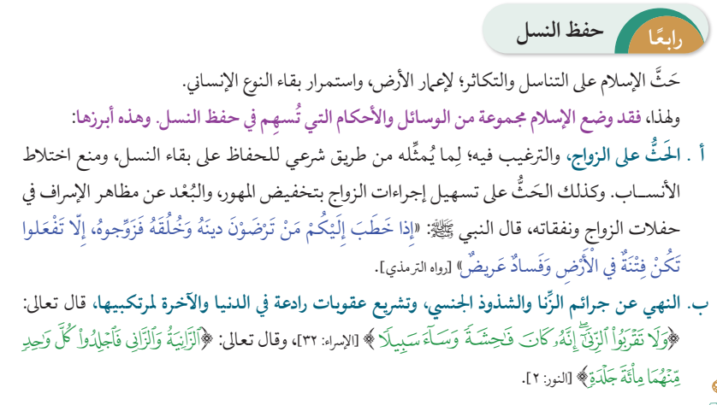
4. Preserving Progeny
Islam encourages procreation and reproduction, to populate the Earth and to preserve the existence of mankind.
Therefore, Islam laid down a series of measures and rules which contribute to preserving progeny. These are the most prominent among them:
[…]

b. Forbidding the sins of adultery and sexual perversion and legislating deterring punishments in this world and in the Hereafter against those who commit them, as God Almighty said: "And do not approach adultery. Indeed, it is ever an immorality and is evil as a way" [Al-Isra' Surah, verse 23], and He said: "The woman and the man guilty of adultery or fornication, flog each of them with a hundred stripes" [Al-Nur Surah, verse 2]
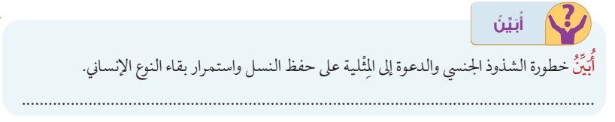
I will explain:
I will explain the danger posed by sexual perversion and homosexual propaganda to the preservation of progeny and the continued existence of mankind.
With respect to the subject of transgender, the curriculum teaches that cross-dressing is prohibited according to Islam. In a chapter discussing clothing in a Grade 10 Islamic Education textbook, students learn that Islam forbids wearing anything that makes a man look like a woman or a woman look like a man. This argument is bolstered by a hadith relating that Muhammad cursed “men imitating women and women imitating men.” Therefore, textbooks use religious texts in order to condemn those who engage in transgenderism.

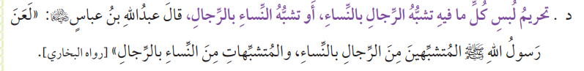
Prohibition to wear anything that makes a man effeminate or women manly [...], the Messenger of God cursed men imitating women, and the women imitating men [narrated by al-Bukhari].
In Jordanian law, transgender identity is not explicitly criminalized, but it is also not protected, in a similar manner to homosexuality. In both cases, the legal framework is defined more by ambiguity than by positive rights: consensual same-sex relations are legal because the Penal Code does not prohibit them, yet homosexuality enjoys no formal recognition or anti-discrimination safeguards. Transgender people, however, occupy a more precarious legal position, as the state has intervened more directly in regulating gender identity through medical law. The 2018 Medical and Health Liability Law effectively bans gender-affirming medical transition by prohibiting “sex change” procedures for transgender individuals, while permitting “sex correction” only in intersex cases, and there is no clear statutory pathway for legal gender recognition. As a result, the legal position of transgender people is more constrained than that of homosexual conduct, which remains legal by omission. This legal distinction, however, is not reflected in school textbooks. Instead, transgender people are described as “cursed” by Muhammad, while homosexuality is portrayed as a form of “sexual perversion.” Neither portrayal accurately reflects the law: homosexuality is legally permitted despite being framed as deviant, and cross-dressing is depicted as deserving condemnation even though it is not regulated by statute. These representations suggest that Islamic Education curricula are shaped less by legal reality than by prevailing religious and social attitudes, with public moral norms informing how both cross-dressing and homosexuality are presented despite their non-criminal legal status.
Egypt:
These findings regarding Jordan’s treatment of LGBTQ rights in textbooks is particularly interesting when comparing them to Egypt’s treatment of the same issues. In Egypt, homosexuality is not explicitly criminalized in statutory law, but it has become de facto illegal through the use of debauchery and public morality laws. Through morality-based prosecutions, Egypt has effectively transformed legal ambiguity surrounding LGBTQ rights into criminalization. The result is a system in which homosexuality is legal in theory but illegal in practice, demonstrating how vague morality laws can function as a proxy for criminalization while allowing the state to deny that homosexuality itself is outlawed.
In contrast to Egypt’s intensive use of debauchery and morality laws to render homosexuality de facto illegal, Jordan exercises far less systematic legal and policing pressure on homosexual conduct, a divergence that one would reasonably expect to be reflected in state-mandated textbooks. However, the rhetoric present in Egyptian textbooks is markedly similar to that of Jordan. In Egypt, despite a far more aggressive enforcement environment, the Grade 9 Maliki Fiqh textbook used in Al-Azhar’s school network frames sodomy in absolutist moral and punitive terms, declaring it forbidden under Islamic law, and prescribing death by stoning for both the active and passive participants, irrespective of marital status or religious affiliation. This material, which has remained unchanged through the 2024–25 and 2025–26 academic years, mirrors the moral condemnation found in Jordanian curricula. The convergence in textbook rhetoric, despite divergent legal and policing realities, suggests that religious doctrine and prevailing social norms, rather than state law, are the primary forces shaping how homosexuality is presented within state-sanctioned educational narratives.
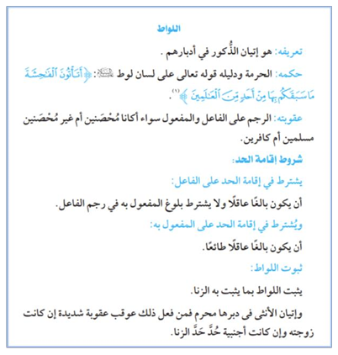
Sodomy
Its definition: male anal intercourse Ruling: it is forbidden, and the proof is God's words as said by Lot: "Why do you commit such indecent acts that have never been committed by anyone before?" Punishment: stoning the active and passive participants, whether they are married or not, and whether they are Muslims or infidels. Conditions for carrying out the punishment: Condition for carrying out the punishment of the active participant: That he has reached maturity and that he is sane. Whether the passive participant has reached maturity or not is not a condition for stoning the active participant. Condition for carrying out the punishment of the passive participant: That he has reached maturity, that he is sane, and that the act was done willingly. Proof for sodomy: Sodomy is proven in the same way adultery is proven. Anal intercourse with a woman is forbidden, and he who does it is punished severely if she is his wife, and if she is not his wife he is punished for adultery.
Transgender identity is not explicitly criminalized under Egyptian state law, but it is severely constrained in practice through medical regulation, morality-based policing, and religious discourse. Access to gender-affirming care is tightly controlled by medical and religious authorities, with approval processes that frame transgender identity as pathological and leave most individuals without treatment or legal recognition. While legal gender change is theoretically possible, it depends on discretionary court and medical decisions rather than a clear legal right. In everyday life, transgender people, particularly trans women, are frequently targeted under public morality, debauchery, and public order laws, leading to arrest, harassment, and detention. As with homosexuality, this produces a system in which transgender identity is legal in theory but rendered unsafe and effectively illegal in practice.
In accordance with this, a Grade 6 Arabic Language textbook, introduced in 2023–24 and retained in 2024–25, describes men dressing as women and women dressing as men as the product of “corrupt influences” that violate human nature and God’s will, framing gender non-conformity as abnormal and immoral. The lesson further stigmatizes LGBTQ identities by teaching students to distinguish the “natural” seven-colour rainbow from a six-colour version associated with corruption. Although neither cross-dressing nor transgender identity is explicitly criminalized in Egyptian law, the textbook promotes early social exclusion and moral condemnation, reinforcing stigma through education rather than legal prohibition.

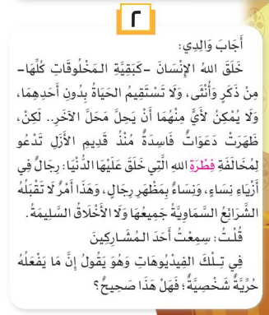
2. My father replied: “God created humans—as with all other creatures—divided into male and female. Life cannot be right without either, and neither can take the place of the other. However, there have been corrupt influences, since time immemorial, calling for a violation of the natural order in which God created the world: men dressing as women, and women dressing as men. This is unacceptable by all divine laws and sound morals.”
In conclusion, the social norms prevailing in Egyptian society are clearly reproduced within state-mandated textbooks, revealing a profound tension between law, enforcement, and education. In Egypt, this tension is particularly stark: practices that are formally decriminalized are nonetheless taught to children as morally wrong, while simultaneously remaining subject to arrest and prosecution through morality laws. Jordan presents a comparatively more consistent legal framework in that homosexual conduct and cross-dressing are generally not prosecutable, yet the negative portrayals found in textbooks similarly diverge from state law and instead reflect prevailing public and religious opinion. Positioned between the contrasting models of Israel and Iran, where Iran exhibits relative legal accommodation of transgender identity alongside severe repression of homosexuality, and Israel extends legal and social recognition to both, Egypt and Jordan occupy an instructive middle ground. Together, they demonstrate that state attitudes toward gender and sexuality are not always mirrored in educational materials; rather, textbooks function as a moral barometer, revealing how societies choose to frame and transmit norms irrespective of legal reality.

